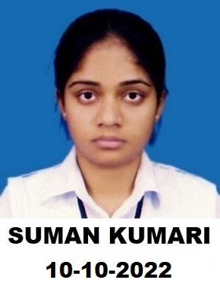
SUMAN SINGH
Vill. – Kela Bela Nai Basti Post – Adalpura,
Dist. – Mirzapur (U.P.) Pin - 231304
Mobile No: +91-7860000000
Email- ja7868888@gmail.com
------------------------------------------------------------------------CAREER OBJECTIVE:
To take up a challenging career which grows with honesty, loyalty, good relationship, best performance, and translate my experience, knowledge, skills and abilities into value for an organization in the field of Research and Development of vegetable crops.
ACADEMIC QUALIFICATIONS:
Degree | School/  Organisation | University/  Board | Year of Passing | Percentage of Marks | Div.
B.Sc.  (Agriculture) | College of Agriculture | MGKVP Varanasi (U.P.) | 2015 | 61.78 | 1st
Intermediate | Sardar Patel Inter collage, Badhaini Babhaniyon, Varanasi (U.P.) | U.P. board | 2011 | 72.60 | 1st
High School | Sardar Patel Inter collage, Badhaini Babhaniyon, Varanasi (U.P.) | U.P. board | 2009 | 54.60 | 2nd
Computer Skills:
Competent in the usage of MS-office, excel, power point & Have good working knowledge of internet. (Computer Course ADCA)
Languages known: Hindi & English
PERSONAL DETAILS:
Date of birth: 05-01-1994; Nationality: Indian; Sex: male; Status: unmarried;
Ideal persons: My Parents and Teachers
PERMANENT ADDRESS: S/O Rajesh Kumar Vill: Kela Bela Nai Basti
Post: Adalpura; Dist: Mirzapur; State: Uttar Pradesh; Pin code: 231304
I confirm that the information provided by me is true to the best of my knowledge and belief. Place: Varanasi
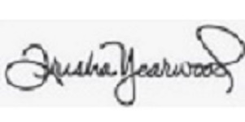
Dated: 01-07-2017 SUMAN SINGH
(Signature)

